# SUMMER TRAINING REPORT ON

# Creating Webpage using HTML & CSS

*A Report Submitted*

*in partial fulfilment for the degree of*

# Bachelor of Technology

# In

# Computer Science & Engineering



**Submitted By:**

Name: **Tej Narayan Sah**

Roll No: **2130314**

**GLOBAL GROUP OF INSTITUTES, AMRITSAR**

# December, 2022

**TABLE OF CONTENTS**

|  |  |
| --- | --- |
| **DESCRIPTION** | **PAGE NUMBER** |
| **Declaration** | **i** |
| **Certificate** | **ii** |
| **Acknowledgement** | **iii** |
| **CHAPTER 1: INTRODUCTION TO PROJECT** | **1-** |
| 1.1 Project Aim & objectives |  |
| 1.2 Project Requirements |  |
| 1.3 Key Feature of project |  |
| **CHAPTER 2: SOFTWARE AND HARDWARE USED** |  |
| 2.1 Software Requirement |  |
| 2.2 Hardware Requirement |  |
| **CHAPTER 3: RESULTS AND DISCUSSION** |  |
| 3.1 Screenshots and its Description |  |
| **CHAPTER 3: CONCLUSION AND FUTURE SCOPE** |  |
| 4.1 Conclusion |  |
| 4.2 Future scope |  |
| **REFERENCES** |  |

## DECLARATION

I declare that this project report titled **Success Revenge** submitted in partial fulfilment of the degree of B. Tech in (Computer Science Engineering) is a record of original work carried out by me under the supervision of Er. Gurleen Kaur and has not formed the basis for the award of any other degree or diploma, in this or any other Institution or University. In keeping with the ethical practice in reporting scientific information, due acknowledgements have been made wherever the findings of others have been cited.

Date: Signature

Name of the candidate: **Tej Narayan Sah**

Roll No.: **2130314**

Examined By:

1) 2)

Er. Gurleen Kaur Prof. (Dr.) Meenakshi Sharma (Project Guide:) (Head of Department)

**CERTIFICATE**

This is to certify that **Tej Narayan Sah** of class **B-Tech (CSE) Semester 3rd** has successfully completed his/her project on topic **creating webpage using HTML & CSS** as prescribed by Er. Gurleen Kaur during the academic year July 2022 to December 2022 as per the guidelines given by **Computer Science and Engineering.**

Signature of external

## ACKNOWLEDGEMENT

I would like to express my gratitude and appreciation to all who gave me the possibility complete this project.

I received a lot of help from several people to complete this project. I would want to thank everyone who helped with this project. I want to thank my Head of Department Dr. Meenakshi Sharma and my mentor Er. Gurleen Kaur, who taught me a lot about this project. Their suggestions and remarks were helpful in finishing this project.

I am appreciative that the college administration gave me such a huge opportunity. I think I’ll take part in more of these kinds of activities in the future. I certify that this project is authentic and that I am solely responsible for its creation. Finally, I’d want to thank my parents and friends for their insightful criticism and support while I completed this project.

Name: Tej Narayan Sah

Roll No: 2130314

# CHAPTER - 1 INTRODUCTION TO PROJECT

**1.1 Project Aim & objectives**

* To make the organization familiar to the market
* To increase the organization, sell and stock
* Make available of different countries writer’s books easily
* To share the organization information to foreign country stockiest
* Get easy access of foreign books and traditional books

**1.2 Project Requirements**

* HTML
* CSS
* Different books images (source: chrome)
* Internet
* Knowledge of VS-code and notepad
* Knowledge of PowerPoint to construct rough view of webpage
* Users focus and punctuality

**1.3 Key Feature of project**

* Free delivery with order tracking
* Cash on delivery as one of the payment methods is available
* valuable products are available at very cheap cost
* Additional discounts should be there for most visitors
* Flexible delivery dates

**CHAPTER 2: SOFTWARE AND HARDWARE USED**

**2.1 Software Requirement**

* Platform: VS-code / Notepad
* We browser: Chrome / Edge

**2.2 Hardware Requirement**

* Processor: 12th Gen Intel(R) Core (TM) i5-12500H 2.50 GHz
* Installed RAM: 16.0 GB (15.6 GB usable)
* System type: Windows 11 Home Single Language
* External input devices (like keyboard, Mouse)

**CHAPTER 3: RESULTS AND DISCUSSION**

**3.1 Screenshots and its Description**

**Home Page**

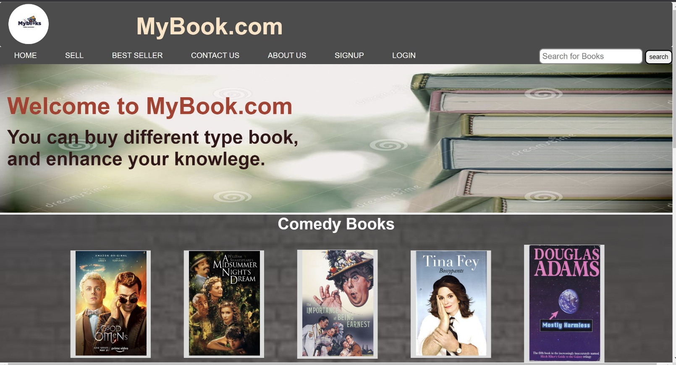

**Sell page**

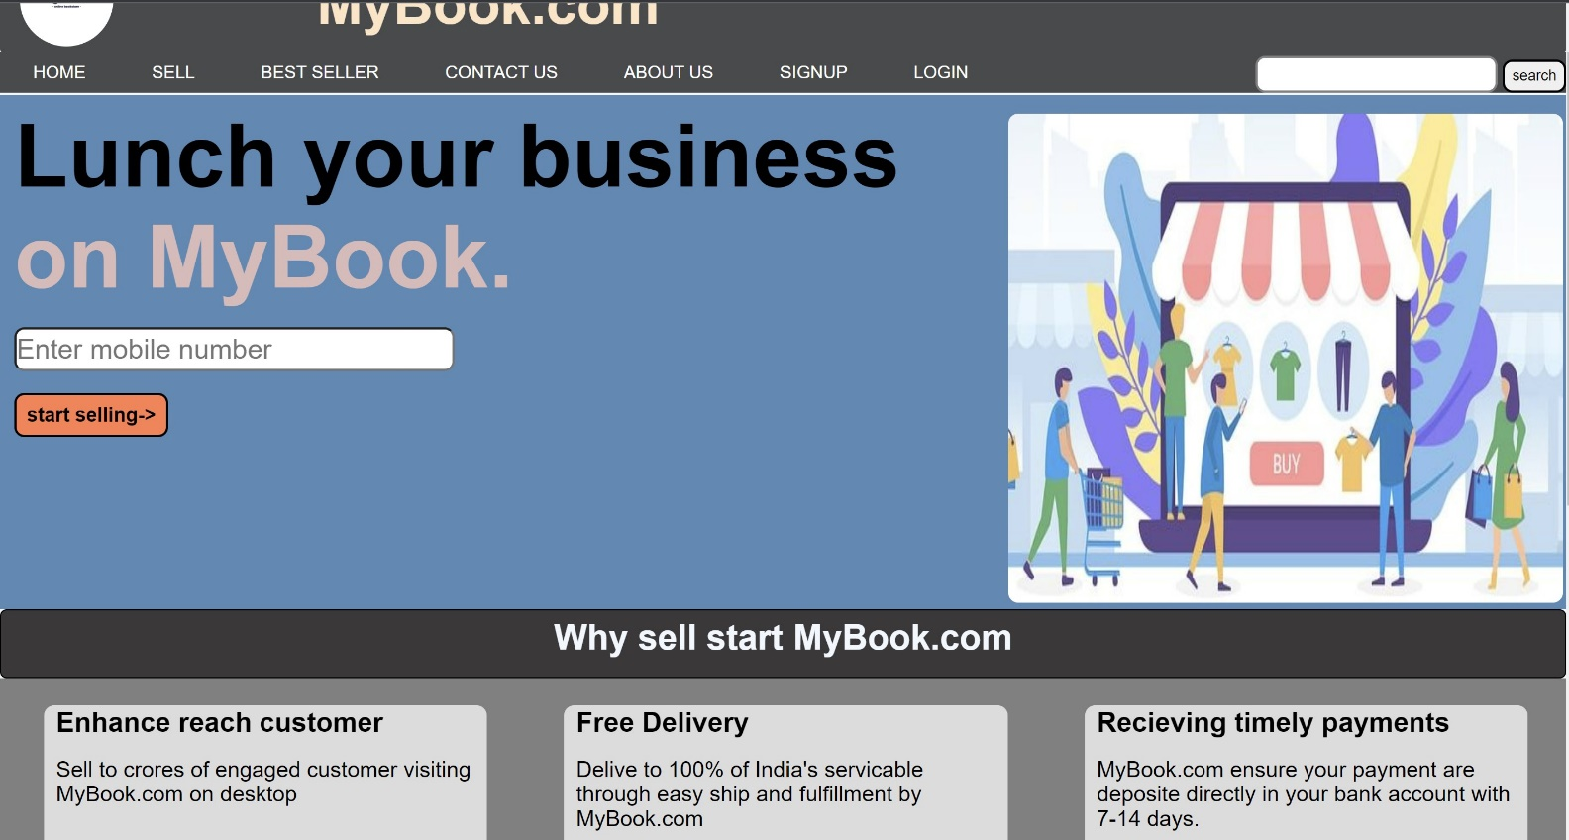

This page helps the seller to start the new store in MyBook.com.

It helps to create new seller user id and further get grow as their own business. Visitors will get maximum discount after getting user id to grow their business and make profit with high margin.

**Best Sellers**

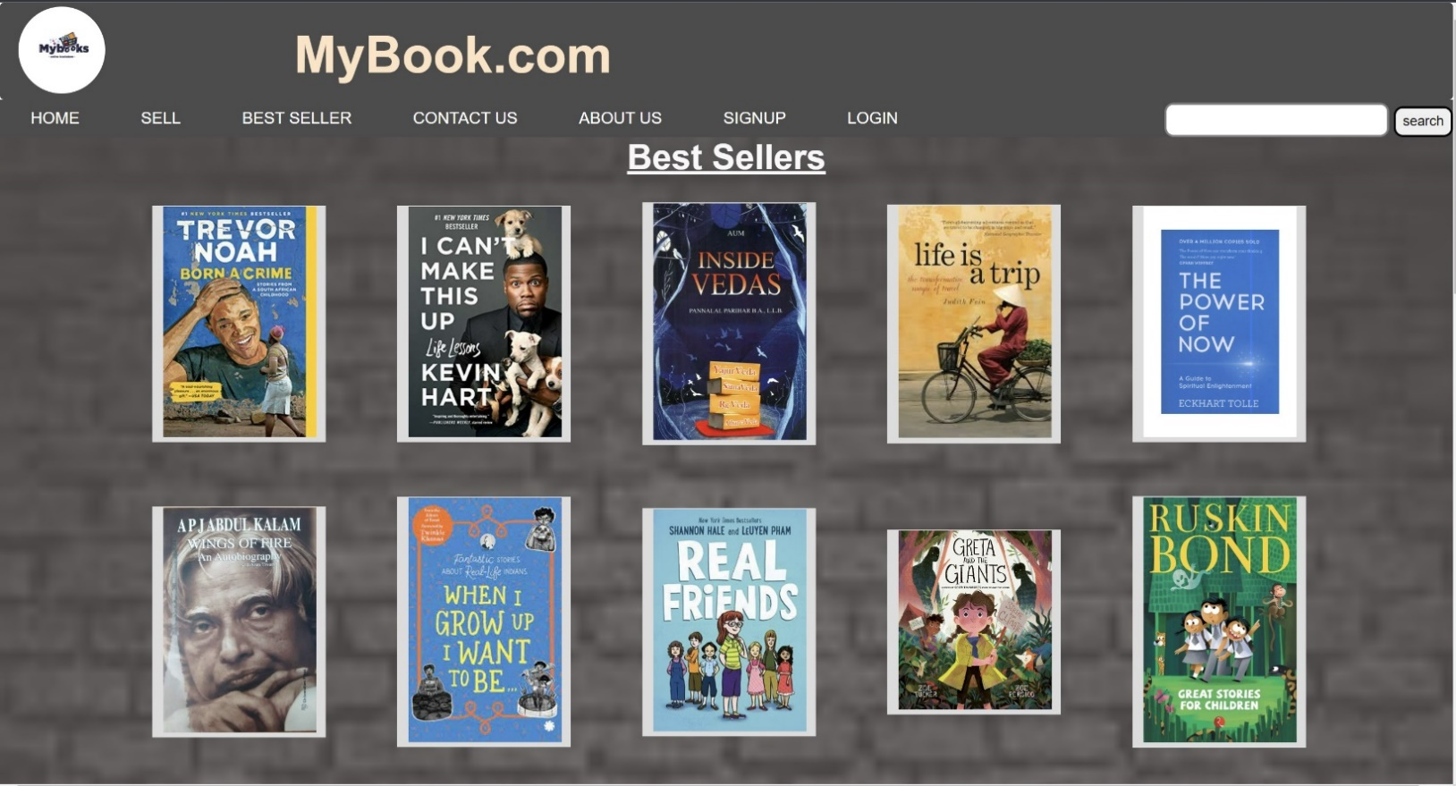

This page help the visitors to find the best seller.

**Contact Us :**

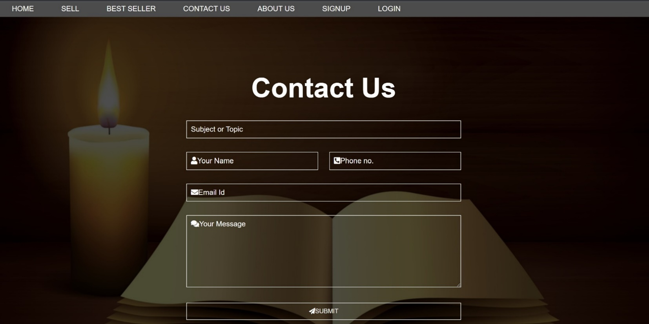

This page is mainly design to get the feedback from the users through their E-mail id. Through which we can manage our weak point and support the users demand. Also, every feedback helps us to push our rating point for the web.

**About us:**

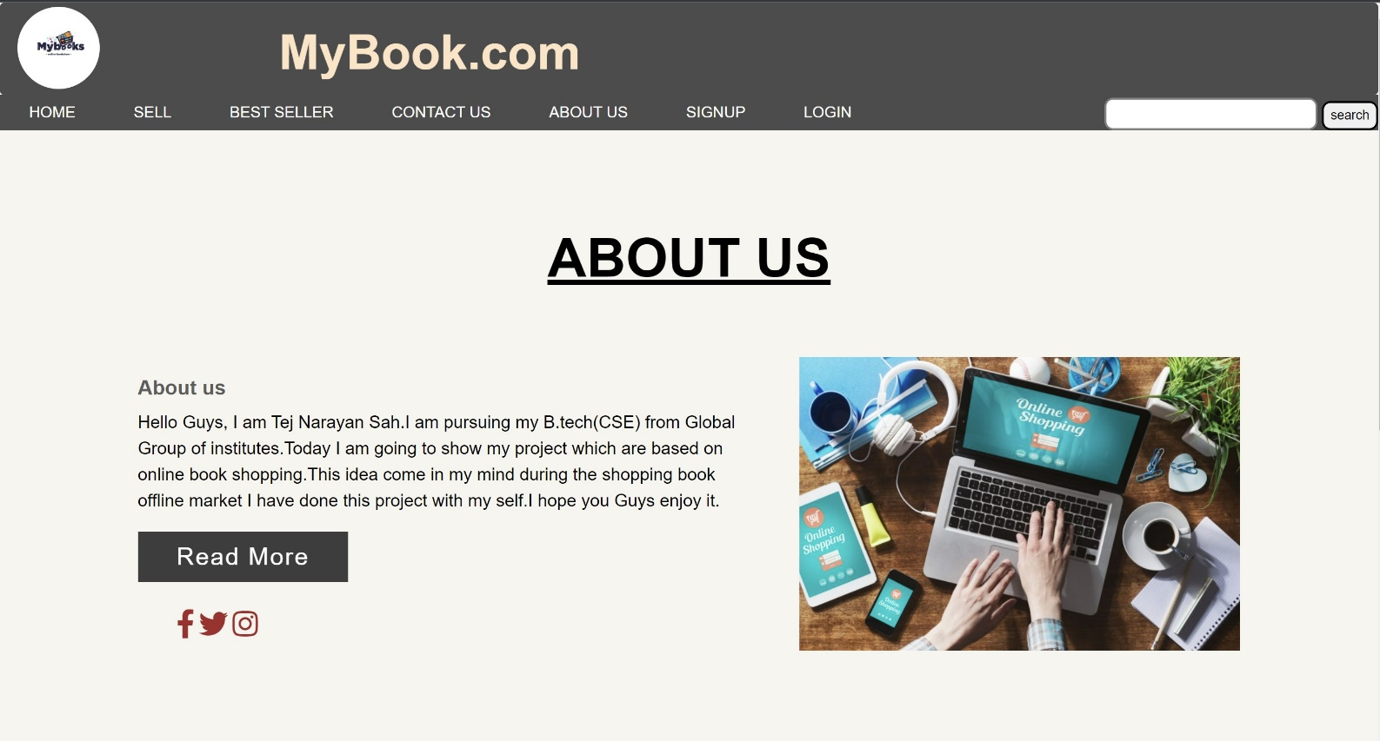

This page is designed to communicate our mission and vision.

Where our mission is to provide us an abundance of books and ongoing literacy support to families and their children from birth and serves as a model for communities committed to ensuring that children are lifelong readers and learners & vision is Our vision is of a world in which reading, learning, and access to information are considered rights, not privileges, so that all children thrive.

**Sign-Up page**

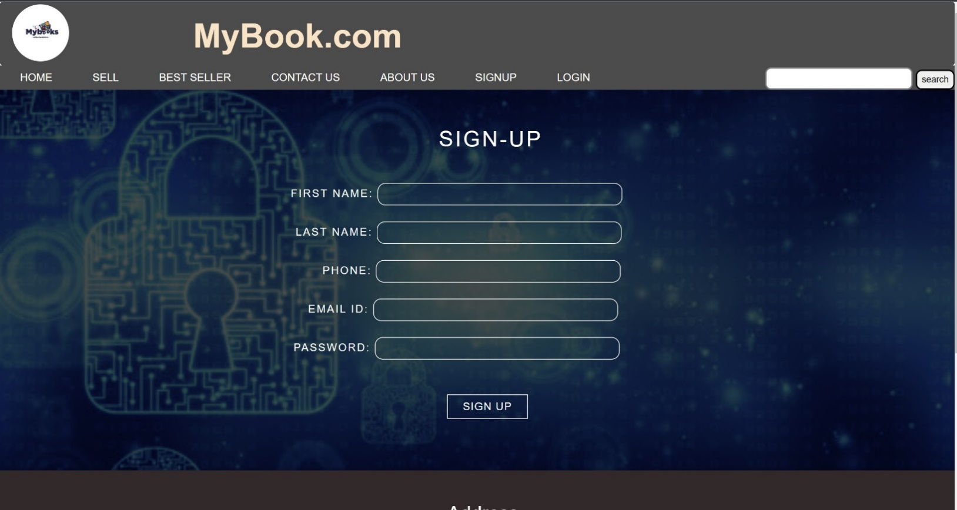

This page helps the users to create new user account free of cost. After created the user account we will get purchase the different types of books. And also, able to contact our support team.

**Login page**

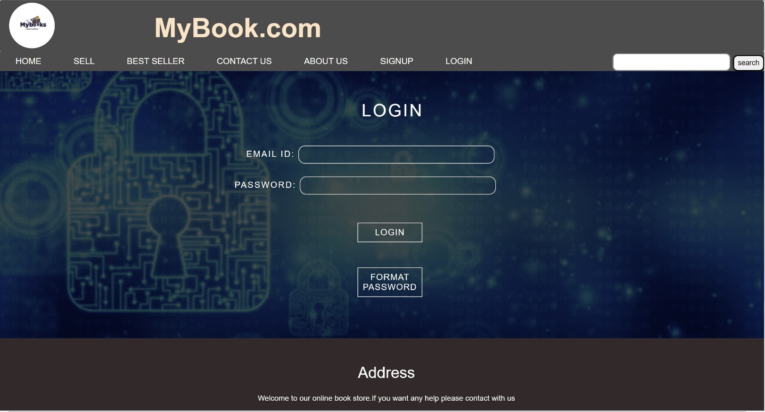

The login page allows a user to gain access to an web side by entering their E-mail id and password

**Footer deign**

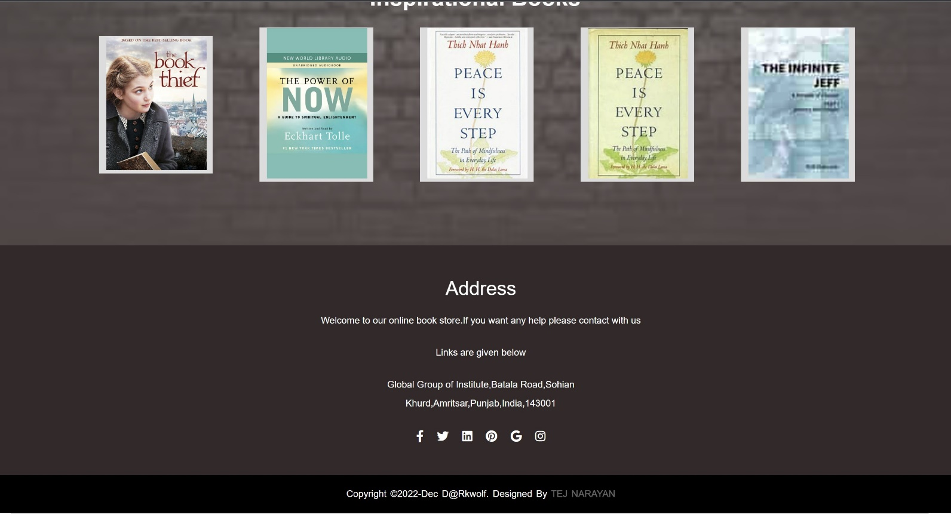

This page provides the information about our organization main address. By visiting particular address client can get direct contact with the organization manager and also get the solution of their particular problem which cannot be solved through online media.

**CHAPTER 3: CONCLUSION AND FUTURE SCOPE**

**4.1 Conclusion**

This project that I undertook was truly a very rewarding experience for me in more than one way. It has given a big thrust to my technical knowledge as prospective Software professional. It has also helped me enhance my skills on the personal front. And I feel extremely satisfied by the fact that I have managed to develop the project of course with equal contribution from my team members. I think I have exploited the opportunity that came my way to the fullest extent by increasing my technical know-how and also gaining the valuable work experience apart from studying the other subjects in our curriculum.

**4.2 Future scope**

The system recommends a facility to accept the deal of stock business between clients and organization manager. It also provides Books or related content according to demand as soon as possible which can make website visitor happy and full of content according to their desire. If possible then in future this webpage will make available different costly books and most studied books in free of cost. Since the application is available in the smartphone, it is easily available and accessible.

**REFERENCES:**

Books pdf, images, contents are downloaded after a very deep and quality research from different motivational websites using chrome web-browser. Some of the content are added from own life e learned lessons and experience.

Some of the reference links are:

* <https://cdn.penguin.com.au/covers/original/9781585428960.jpg>
* <https://m.media-amazon.com/images/I/81zz6LqCreS._AC_UY218_.jpg>
* <https://th.bing.com/th/id/OIP.ref0e_qIaDg8bYOHKKA9jQHaE8?pid=ImgDet&rs=1>
* <https://th.bing.com/th/id/OIP.tLQllNLG7fl0waAn5nYzIAAAAA?pid=ImgDet&rs=1>